Equation is:

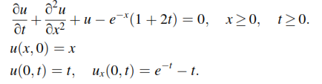

Fourier transform of equation is:

