……………………………….1

……………………………………………………………………………….2

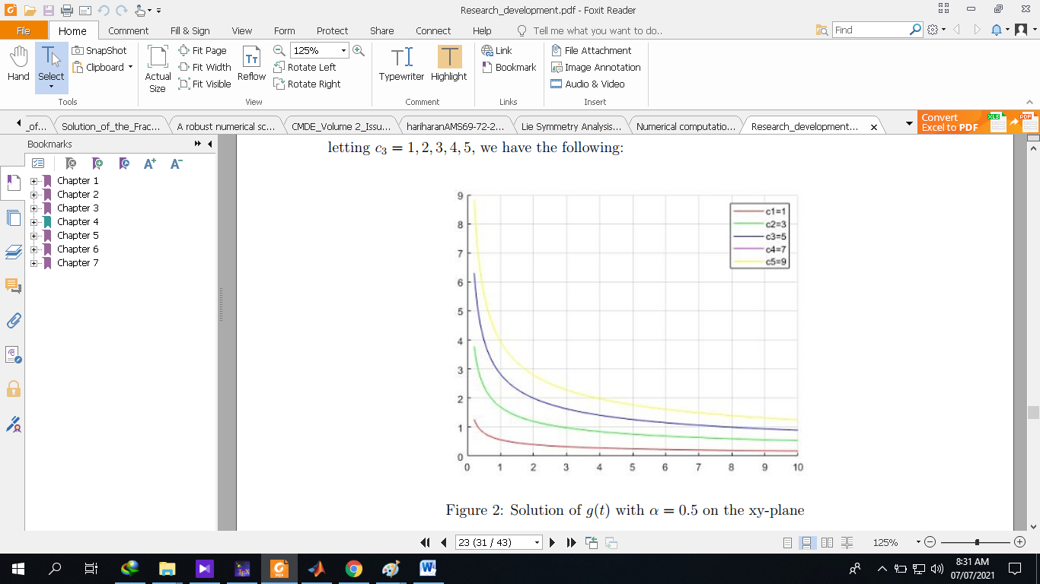…………………………………3

Equation 1 is a fractional black-scholes equation where r is the risk free interest rate,=volitality,upon using Lie symmetry techniques, I managed to solve it and found the invariant solution which is given by (2), (3) is the graphical solution of (2). Now I need help on how I can plot equation 1 and compare and intepret obtained solution with 3. How can I do all this using maple? And how can I plot all the information in one figure? Thank you.