Dear thanks alot, this code is working. kindly help me more .

Actually, i want to transform the following equations

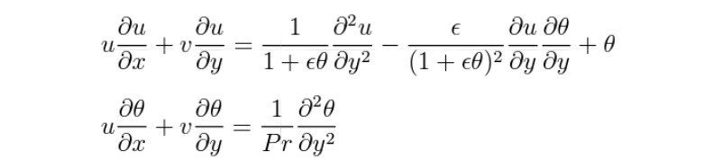

By using

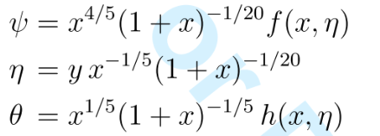

To get the following form

