The Audion Planck’s law

Planck’s distribution law of black-body for photons of Bose statistic is ^{[1]}: ${dN}_{ω}=\frac{V}{π^{2}c^{3}}\frac{ω^{2}dω}{e^{\frac{hω}{T}}-1}$ (1)
where V is the volume of photonic gas. Or we can multiply with h·ν to obtain the spectral distribution in the interval ω & ω + dω so the energy density: $dEω=\frac{Vh}{π^{2}c^{3}}\frac{ω^{3}dω}{e^{\frac{hω}{T}}-1}$ (2) with ω = 2πν and N(ν) = $\frac{8π{Vν}^{2}}{c^{3}}$ and V is the quanta of photonic gas with cylindric symmetry of the height of the cylinder is Tq·c and with radius r and aria π·r² thus the volume (V) of photic gas has the value Tq·c·π·r² => the energy per quanta Tq is $E_{νTq}=N(ν)·U\left(ν,T\right)=\frac{Tq·c·r^{2}·8π^{2}ν^{2}}{c^{3}}\frac{E_{νq}}{e^{\frac{E_{νq}}{kT}}-1}$ So E_{νTq} = U(ν,T) ·N(ν) Thus per time Tq so we have
$dE_{Nν}=\frac{r^{2}·8π^{2}ν^{2}}{c^{2}}\frac{E_{νq}}{e^{\frac{E_{νq}}{kT}}-1}dν$ Where U(ν, T) (or < E >) is the internal energy $U\left(ν,T\right)=\frac{hν}{e^{\frac{hν}{kT}}-1}$ written $\frac{E_{νq}}{e^{\frac{E_{νq}}{kT}}-1}$ and $\frac{8πν^{2}}{c^{3}}$ are the number of states of the oscillators times the volume of photonics gas Tq·c·π·r² so the energy quanta at frequency ν is approx. E_{νq} ~hν.
The differential energy quanta for a photon with velocity c is:
$dE_{Nν}=\frac{r^{2}·8·π^{2}{·ν}^{2}}{c^{2}}\frac{E_{νq}}{e^{\frac{E_{νq}}{kT}}-1}dν$ (3)
For the unit energy per time unit per angle unit and an interval of frequencies between (100nm-3μm), one should have approximative the Plank’s formula. For photons, we assume that the quanta energy is different than Planck law E ~ h⸱ν thus for the frequency of extended UV, visible light to infrared is usually 100nm - 3μm. Likewise, we admit that the Planck distribution law of blackbody is valid (1) but quanta energy is slightly different from E ~ hν, depending on the frequency. Thus the infinitesimal value is proportional to the derivate of Planck’s distribution law of blackbody diff(dE(ν,T),ν). The energy is the sum of infinitesimal in a period t = 1/ν so we integrate on Time Quanta:
$E_{ν}= \int_{t_{0}}^{t_{0}+Tq}{diff{(E}_{Nν},ν)dt}$ where Tq is the time quanta for the photons (the time in which light travels the Bohr radius Tq = 1.765·10⁻¹⁹ sec). Thus, for a wide range of frequencies in visible light, the law should be E ~ h⸱ν (100nm - 3μm). Thus at λ going down to -> 3nm the quanta of energy drop for a fall to 0. We have two cases for large ν thus $e^{\frac{E_{νq}}{kT}}≫1$ the exponential is dominated and for low frequency where ν < 10¹⁴ Hz.
The Modified Plank’s Law for the photons link: http://www.michaelvio.byethost8.com/PPh1.pdf
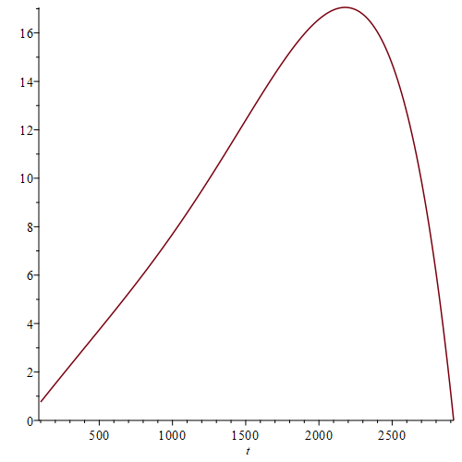
For the audion we have: the infinitesimal energy spherical symmetry and for audion with velocity v_{a}, 343m/s is: $dE_{Nν}=\frac{32π^{2}ν^{2}·r_{b}^{2}}{3·c^{2}}\frac{E_{νq}}{e^{\frac{E_{νq}}{kT}{\left(\frac{c}{v_{a}}\right)}^{2}}-1}dν$ (4) and for audion in the air the time quanta is the time that sound travels the distance of Bohr radius. T_{q1} = r_{Bohr}/v_{a} = (0.529/343)·10⁻¹⁰ => The audion’s Time Quanta T_{q1}=1.54297·10⁻¹³s. The volume of gas with spherical symmetry V = (4/3)πr_{b}³ per quanta of time T_{q1} and speed v_{a}:
${dE}_{Nν}=\frac{32π^{2}ν^{2}·r_{b}^{2}}{3·c^{2}}\frac{E_{νq}}{e^{\frac{E_{νq}}{kT}{\left(\frac{c}{v_{a}}\right)}^{2}}-1}·dν$ where the factor (c/v_{a}) ² is relative to the kinetic energy (5)
As a result of equation (4) thus we change variables derivate and integrate on a quanta of time:
$E_{ν}=\int_{t_{0}}^{t_{0}+Tq1}{d\left(E_{Nν},ν\right)dt}=\int_{t_{0}}^{t_{0}+Tq1}{diff\left(\frac{32π^{2}ν^{2}·r_{b}^{2}}{3·c^{2}}\frac{E_{νq}}{e^{\frac{E_{νq}}{kT}{\left(\frac{c}{v_{a}}\right)}^{2}}-1},ν\right)dt=}\sim polinomial series…$ (6)
For simplification, we assume that the energy of the audion is E_{A} = 0.00762014687· ν – h_{a1}·ν²…until h_{a4} ν⁵
Where I guess the first coefficient 0.00762014687 from several values of energy as E = 3.259eV for ν = 435Hz

^{[1]} Landau & Lifshitz Vol.9 Statistical Physics Cap 5 Paragraph 63 Black-body Radiation (63.4) page 184
9 Oct. 2024

