|  |  |
| --- | --- |
| (4) |  |



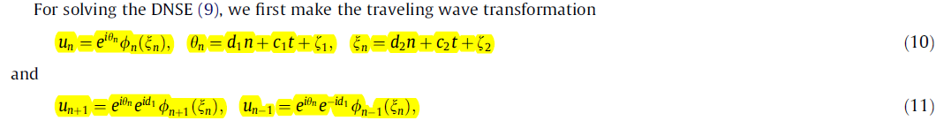

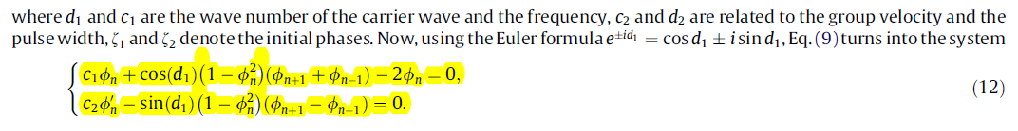



|  |  |
| --- | --- |
| (13) |  |
|  | where |
|  |  |

