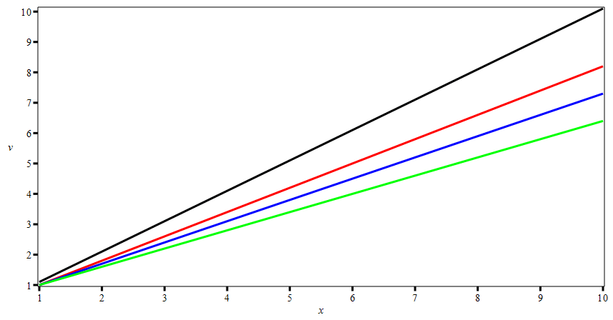

Above is exported from Maple as a GIF

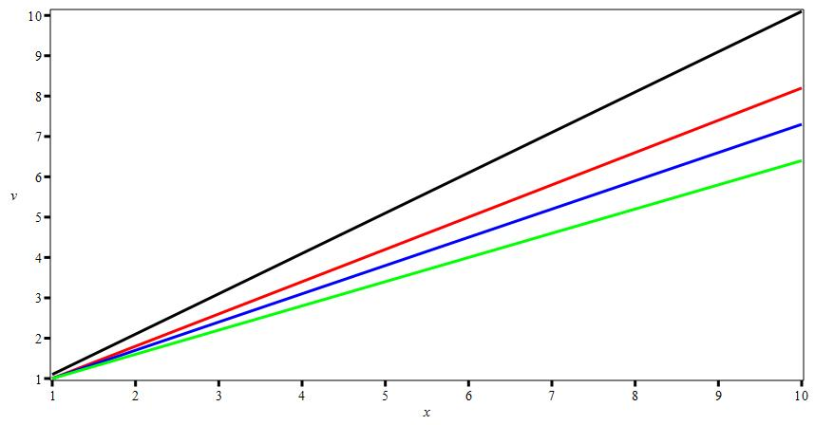

Above is exported from Maple as a JPEG

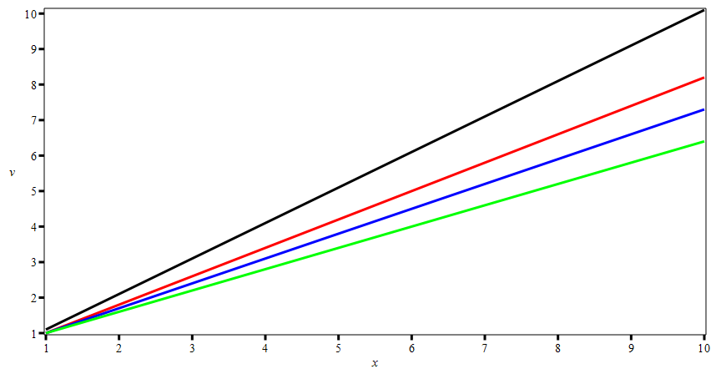

Above is exported from Maple as PNG